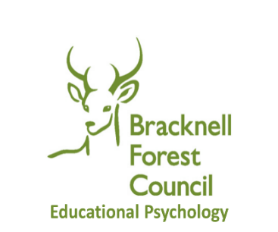
During the first Covid-19 lockdown, the Educational Psychology Service offered telephone consultations for parents/carers to support with challenges which arose with children and young people during this period of significant change. Although things have moved on since then, the impact of Covid on the wellbeing of some children, young people and families remains significant. In response to feedback from our schools, and funded through the government Wellbeing for Education Recovery grant, we will be offering parent/ carer telephone consultations during the Spring term of 2022.
Educational Psychologists (EPs) have expertise in child development, learning and psychological wellbeing. We work collaboratively with children, young people, their families and the professionals who work with them in a range of settings to promote positive change, progress in learning and emotional wellbeing. This is an opportunity for you to discuss, in confidence, any issues which you are struggling with or concerned about in regard to your child /young person. The focus will be on emotional wellbeing but may also include issues relating to learning, relationships, behaviour and communication.
What’s on offer
- You will be able to access a confidential 30-minute telephone consultation with an EP or Trainee EP
- These sessions are open to any parent/carer of a Bracknell Forest child or young person (0-25)
- The aim of the session is to provide parents / carers with an opportunity to discuss any concerns and to think through how to move forward with the situation
- Our hope is that by having some time to discuss and reflect on your situation, you will feel better able to cope with your situation and will also have identified some strategies/ways forward
- This is a stand-alone session so there will be no follow up and no written record of the session will be kept
- We will keep a very brief record of issues discussed for our administrative and monitoring purposes
- Places are limited and will be offered on a first come first served basis
What will be covered?
You are the expert on your child/young person and so we will ask some questions to explore and better understand your concerns. These may include:
  - your child/ young person’s strengths and needs
  - key issues for your child/young person
  - what things you have already been able to do to support your child/young person
  - what your best hopes are for a way forward
You may find it helpful to jot down, in advance, key information you would like to share or to make a note of any questions that you want to ask. It may also be helpful to make some notes during the consultation.
All that we ask of you is that you provide us with some brief feedback after the session.
For booking details see the next page. Please complete the table and send to the EPS email address provided. Bookings can only be taken via email and following receipt of a completed booking form (below).
Parent /Carer Telephone Consultation sessions
Educational Psychology Service
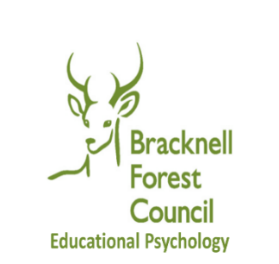
Booking Form
Parent / Carer Telephone Consultation Sessions
with an Educational Psychologist Spring 2022
*Each session is scheduled for 30 minutes
Green denotes available sessions

 | 9:15 – 9:45am |  | 10am – 10:30am |  | 10:45 – 11:15am |  | 11:30am – 12pm |  |  | 1.15pm-1.45pm | 2pm – 2:30pm | 2:45 – 3:15pm | 3:30 – 4pm
Thurs 3rd March | No sessions available
Friday 4th March | No sessions available
Tue 8th March |  |  |  |  |  |  |  |  |  | No sessions available
Wed 9th March | No sessions available
Fri 11th March |  |  |  |  |  |  |  |  |  | No sessions available
Tue 15th March |  |  |  |  |  |  |  |  |  | No sessions available
Wed 16th March | No sessions available
Thurs 17th March | No sessions available
Mon 21st March |  |  |  |  |  |  |  |  |  | No sessions available
Tue 22nd March |  |  |  |  |  |  |  |  |  | No sessions available
Thurs 24th March |  |  |  |  |  |  |  |  |  | No sessions available
Mon 28th March | No sessions available
Wed 30th March |  |  |  |  |  |  |  |  |  | No sessions available
Thurs 31st March | No sessions available

To book a parent / carer phone consultation with an EP, please complete the following table and send to Educational.Psychology-Service2@bracknell-forest.gov.uk – please write ‘PCEPX’ in the email subject line to indicate it is a parent consultation booking request.

Child / Young Person’s Name: |  |  |  |  |  |  |  | Child DOB:
Name of person referring/ relationship to child
Mobile telephone number: |  |  |  |  | Email address
Summary of item / issue you would like to discuss with an EP
Preferences – session requested (date / time) |  | 1st  preference |  |  |  | 2nd  preference |  |  | 3rd preference
I consent to sharing my contact details with Bracknell Forest EPS as part of the telephone consultation process. Once a session has been agreed and confirmed I agree to an EP from Bracknell Forest contacting me on the details I provided above to discuss the issue / item I want to explore.
Signed: |  |  |  |  |  |  |  | Date:
*Please try to provide three preferences / options, as this will increase the likelihood of accessing a consultation session.

