English - Summer 2 Week 4 - Home Learning

Session 1

In today’s session, you will be identifying language features associated with the horror genre.

You will start today’s session by watching two clips, each time answering several questions about them. After that, you will look at physical and emotional responses caused by this genre of writing/media.

Finally, you will look at a story called ‘The Visit’, answer the questions about it and create a story map of this.

How to share your work:
- Write your answers into your exercise book and take a picture of your work.
- Type your answers directly into the boxes on this page or use Google Docs to edit.
- Your story map can be completed however you wish.
Once you’ve completed the work, submit your work to Google Classroom following this set of instructions:
- Go to classroom.google.com
- Click the class - Classwork - the assignment.
- To attach an item, click ‘Add or create’ and select ‘Google Drive’, ‘Link’ or ‘File’ depending on what type of file you have created.
- The status of your work will change to ‘Turned in’.

Horror Media

First, watch this ‘Graveyard’ video on YouTube and answer the questions about it: https://www.youtube.com/watch?v=TmN_He6e-AA

How does it make you feel?
Click or tap here to enter text.

What type of genre is this clip from?
Click or tap here to enter text.

How do you know?
Click or tap here to enter text.

Then, watch this ‘Marshmallow’ video BUT STOP AT 18 SECONDS and answer the questions about it: https://www.literacyshed.com/marshmallows.html

How does it make you feel?
Click or tap here to enter text.

What type of genre is this clip from?
Click or tap here to enter text.

How do you know?
Click or tap here to enter text.

Creating Suspense and Tension

When you write a good horror story, your audience will have certain emotional and physical responses which could include:

Physical Responses Include | Emotional Responses Include
Skin - chills and sweating  Heart - beats faster and harder  Muscles - become more tense  Lungs - quick, deep breathing occurs | Fear  Panic  Anxiety  Stress

Now watch this video clip of Malorie Blackman, the author of some Star Books from our classes which include ‘Hacker’, ‘Pig Heart Boy’ and ‘Thief’. In it, she talks about how you can create tension and suspense in your writing: http://www.bbc.co.uk/programmes/p011mxd6

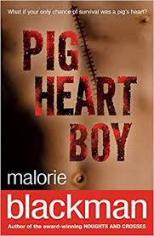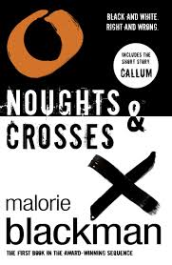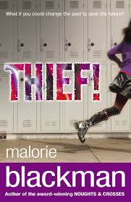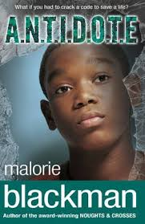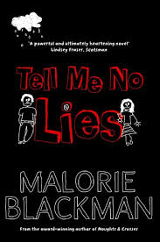
The Visit

“Oh no!” Rebecca cried to herself. She could feel the shape of the card in the lining of her jacket but realised that in the fading light she had no chance of digging it out, or of reading it once she had for that matter. Now how was she to get to Sammy’s house? She thought hard, what had Sammy said? “Once you’re off the bus, go passed the church and it was number... something Longford Drive.”
She set off, determined to find the church. She walked for what seemed like an age but didn’t recognise any of the roads she passed. She walked on, eager to find the church and Sammy and a warm drink! She came to a junction where three roads met. She peered down each but none seemed more promising than the others. She chose a direction at random and walked along the road for five minutes but she found no sign of a church. She stood hesitating, looking up then down the road and peering up a side street, desperate for any sign that a church might be close at hand. She still hadn’t decided which way the church lay in when she spotted someone she could ask for directions. An old lady was sitting quietly on a bench. She was about to ask directions when the woman smiled at her and patted the bench beside her. “Are you lost my love?”
“Yes, I’m looking for a church, my friend lives at the other side, Longford Drive I think.”
“Longford Drive, yes I know it. You are almost there my love…” The lady gave Rebecca directions and wished her, “God’s speed my lovey!” Smiling from her encounter with the old lady, Rebecca carefully followed her directions and came quickly to the gate that led in to the churchyard. She felt nervous about passing through all the graves but knew that ten minutes bravery would see her at Sammy’s door.
She had to summon up all her courage to force herself to push at the old church gate. The heavy iron gate swung open easily, if noisily, and she was soon striding along a gravel path that cut straight through the aisles of graves and down to what must be Longford Road. She was about halfway across when a loud creaking and a bang made her jump. She spun round, nerves ragged at the thought of what she was doing. She thought back to all the horror films she had seen; too many of them had featured the heroine being attacked by zombies or vampires in a churchyard - “I must be a nutter! Next time, I’m getting a taxi.” she muttered, although even to herself, her voice sounded small and frightened. When she saw what had caused the noises, she nearly screamed. The gate she had left wide open, was now very firmly shut. She walked faster towards the lights of the houses beyond the graves, her feet crunching noisily on the gravel. She realised she wouldn’t hear anyone, or anything with all the noise she was making so she moved on to the grass verge. She started to walk again, but after a few seconds she distinctly heard the sound of slow, heavy footsteps behind her. She spun again, but no one was there. She ran this time - flying towards the gate, but it was too far to do in one go. After a few minutes running, she threw herself against an ancient yew. She panted and swore, more scared than she had ever been in her life. Next time ...(gasp)... Sammy... (gasp)...would darn well visit...(gasp)...her!
The creature became aware of a small figure in its territory. A girl clung to a tree, half-sobbing and obviously exhausted, her back was towards the figure. It moved in. 20 metres, 10 metres, closer, well within range…
A hand grabbed Rebecca’s shoulder. She wanted to scream but she was so paralysed with fright that all that came was a mew like a hungry kitten would make. “Hello my dear. I didn’t mean to frighten you.” The voice was old and tired, but kind. Rebecca forced herself to turn and look round. She saw a kindly man with a concerned expression, shabbily dressed and with what looked like a part of his dinner down his front. The man wore a dog collar and the black shirt of a priest. The old vicar peered closely at her, “Come on my dear, you've had a shock, let’s get you home.” Rebecca explained that she was visiting a friend. He knew the road and offered to keep her company on the short walk to Sammy’s house. Rebecca tried to explain why she had been so afraid, but it sounded weak with the comforting presence of the old priest beside her. He explained how the gate would swing in the wind and how he had been having his tea when he heard footsteps on the gravel and gone out to investigate, making the footsteps that had worried her so much. “We’ve had so much stolen; I felt sure you must be a burglar!” he laughed.
When they arrived at Sammy’s house, the priest walked to the door, but once they heard the sound of Sammy bounding the stairs to answer the bell, he turned and waved, “Goodbye my dear – get a lift back!”
Rebecca shouted her thanks after him as he walked back up the path. Then there was Sammy, looking relieved to see her. “Who are you talking to Becks?”
“The Priest from the old church. He’s lovely, isn’t he?” Rebecca noticed that her friend looked surprised and had gone a little pale. “Rebecca, it couldn’t have been a priest – that church is abandoned; nobody goes there since they found the body of the last vicar.”

What makes this a horror story?
Click or tap here to enter text.

How is the suspense created?
Click or tap here to enter text.

The Visit: Story Map

Task: Create a story map of the story ‘The Visit’. Your story map can form an S shape, be along a timeline, on a story mountain or be like a story board. You can present it however you wish but it must contain the following:
- Pictures
- Arrows leading from one event to the next
- A phrase from that section to show character, setting or atmosphere

Help: Character tells you about a character. The way they look, act or feel. E.g. “She felt nervous”.
Setting tells you about the place where the character is. E.g. “a junction where three roads met.”
Atmosphere shows suspense and tension. E.g. “gasp…”

