Reading - Summer 1 Week 5 - Home Learning

Session3

Today, you are going to share your response to the story by thinking about the images you have made in your mind from reading it, by thinking about the words or phrases that you particularly liked and by using those ideas creatively.

Re-read the story and think about the words you chose in session 1. Then look at the attached images which will hopefully help you imagine the scene. From this, decide how you want to represent your feelings and ideas. You can draw a picture, write a poem or do a bit of both. For instance, you could draw a picture of the copse at the top of the hill and then write some of the words you liked around it as a sort of frame to your picture. There is no right or wrong – this is all about your feelings and responses so be bold and creative and we will love seeing your ideas!

You can enter ideas directly onto the final page, but it may be easier to do this on paper, drawing or colouring your picture or words.

How to share your work:
- Write your answers into your exercise book and take a picture of your work.
- Type your answers directly into the boxes on this page or use Google Docs to edit.
Once you’ve completed the work, submit your work to Google Classroom following this set of instructions:
- Go to classroom.google.com
- Click the class - Classwork - the assignment.
- To attach an item, click ‘Add or create’ and select ‘Google Drive’, ‘Link’ or ‘File’ depending on what type of file you have created.
- The status of your work will change to ‘Turned in’.

Trappers Hill

Den paused for breath at the first ring of earthworks. He could feel his heart rate finally returning to normal, despite the hard climb, so he reckoned he had put enough distance between himself and home. Of course, he would go back – just not yet. Everyone would need a little more time to calm down.
Looking around, he could see the sun edging closer to the horizon. Even so, he felt there was enough time to stay out a little longer and still get home before darkness descended completely. He would certainly appreciate the solitude. He relaxed as he watched the last day-visitors departing through the gate far below, leaving him the last living soul on the hill.
He had always loved this sacred place. Centuries ago, Trappers Hill had been an Iron Age hill fort – hence the earthworks. A small chapel had once stood at the top where now there was a small copse of beech and horse chestnut. It had even been the sight of a gallows, offering a warning to any who considered highway robbery to be a worthwhile occupation.
Having regained his breath, Den decided to see if he could find the shallow old maze that lay beyond the copse. Local legend said that it had been cut into the rabbit-cropped turf of the hillcrest by a lonely pupil from the ancient boarding school down in the town. Desperate to escape the jibes of his privileged classmates and the beatings of his strict masters, the poor lad would flee to this spot whenever he could.
Emerging from the trees, Den saw through the gathering gloom a figure standing in the middle of the maze. Trying to mask his disappointment, he approached with a mixture of caution and curiosity. Who else could possibly want to be up here at this time? The silence was shattered by the squabbling rooks high in the trees. The figure turned to look at Den. It was a boy – pale, thin, probably around ten or eleven. There was a sadness in his eyes, yet he managed a smile, saying, “Now I’ve got to find my way out again. I say, could you help me?”
“Why don’t you just walk straight across?” replied Den, feeling suddenly rather chilly and noticing that he was now in the shadow of the woods.
“Ah, now that wouldn’t be playing the game, would it?” countered the boy with a hint of a smile. “The right thing would be for you to follow the maze into the centre and then you can lead me out.”
“Well, I really ought to …”
“Go on, I dare you,” interrupted the lad. “You’re right by the beginning. How difficult could it be?”
Against his better instincts, he took a first step into the shallow trench that marked the entrance. He was now approaching the first turn.
Suddenly, Den was struck by a deep sense of foreboding. He tried to cut across the maze but, strangely, he couldn’t. He turned and retraced his footsteps.
“Wait! What are you doing?” cried the boy but Den didn’t stop to answer. By the time he was back at the entrance, he was sprinting. He bolted back through the copse and stumbled down the hill.
Back on the hilltop, the rooks squawked their disappointment and the figure disappeared.

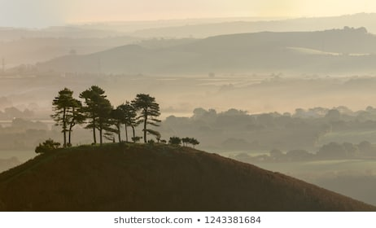
Lonely copse at the top of a hill.

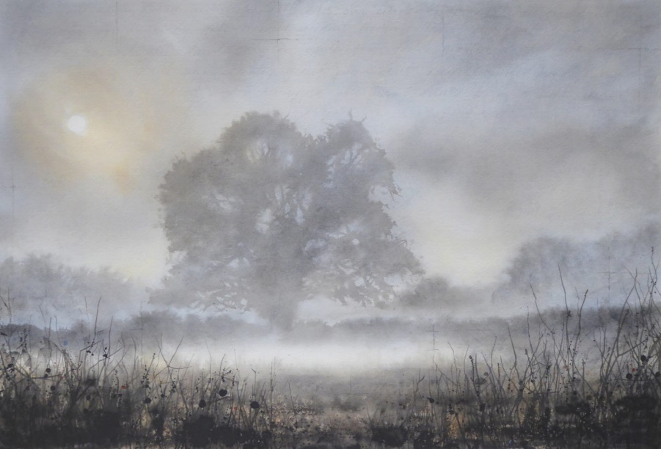
Tree in the mist at dusk.
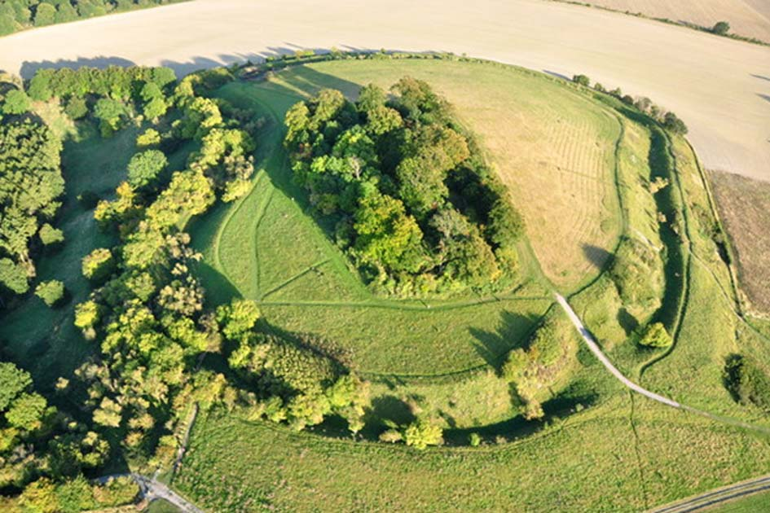
Aerial view of ancient earthworks.
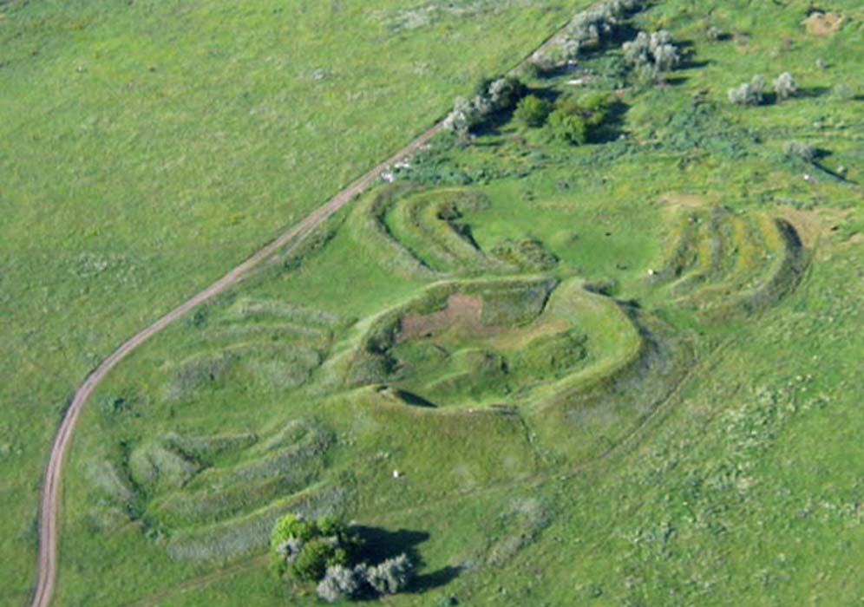
Aerial view of ancient earthworks.
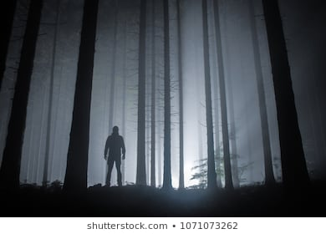
Child in the woods.

Click or tap here to enter text.

