Reading - Summer 1 Week 4 - Home Learning

Session 1

Today, you need to read the text about the mountains in Europe called the Alps. There are some technical words in the text which you may not have come across before so look them up online or in a dictionary. Using this knowledge, complete the definition match up activity. You can do this by clicking onto the entry boxes and typing directly onto the document, by printing it off and entering your answers, or by writing your answers into your exercise book.

How to share your work:
- Write your answers into your exercise book and take a picture of your work.
- Type your answers directly into the boxes on this page or use Google Docs to edit.
Once you’ve completed the work, submit your work to Google Classroom following this set of instructions:
- Go to classroom.google.com
- Click the class - Classwork - the assignment.
- To attach an item, click ‘Add or create’ and select ‘Google Drive’, ‘Link’ or ‘File’ depending on what type of file you have created.
- The status of your work will change to ‘Turned in’.

Text - The Alps

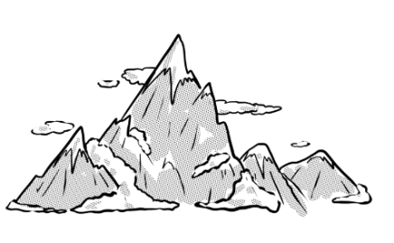
One of the most dominant geographical features of western Europe is the vast mountain range known as the Alps. The Alps extend from the Mediterranean coast of south-western France across to Germany, Austria and Slovenia in the east. Other countries, such as Switzerland, Italy and tiny Liechtenstein also include sections of this rugged landscape. With peaks as high as 4,800m (Mont Blanc), the Alps are high enough to affect the climate of the whole continent.

Formation
The Alps are part of a series of mountain chains, running from the Atlas Mountains in northern Africa right across to the Himalayas north of India, that were formed by the same basic process. The Earth’s crust is made up of a number of massive sections called tectonic plates. These are continuingly moving, slowly but incredibly powerfully. When the African plate to the south started inching northwards, it collided into another plate which covers much of northern Europe. The extraordinary pressures generated by this process caused the land to be pushed up, much like a tablecloth will form ridges if you push it across a table.

The process of raising and shaping the Alps has not finished, however. The area is still prone to powerful earthquakes. Meanwhile, the weather plays a large part in wearing down the rocks. This includes the action of glaciers. These slow-moving rivers of ice help to carve out huge valleys, some of which have been lined with a thick layer of sand and gravel, dumped by the melting glaciers.

Features
The sheer height of these mountains means that moist air gets snagged on the peaks, resulting in heavy snowfalls. Large parts of the Alps remain snow-capped all the year round, although it melts away from the lower slopes during the warmer months. This leads to many of the valleys being flooded to create deep lakes. It also helps to irrigate the surrounding land and contributes to some of the largest rivers in Europe, including the Rhône, the Rhine and the Danube.

Life
The Alps provide a number of different habitats. At lower levels, there are meadows, bogs and woodland. Above the treeline, the conditions are harsher and animals as well as plants have had to adapt to survive.

Possibly the most famous plant is a little flower called the edelweiss. The most common name of this tough little relative of the daisy comes from German words meaning noble white. However, it is also known by other names, depending on which country you are in. For example, the French call it Etoile des Alpes, which means the star of the Alps.

As for the animals, the ibex is probably the most impressive. This member of the goat family lives on the rocky mountainsides above the forests. An expert climber, it shelters from the snows in caves and enjoys the safety of slopes as steep as 45 degrees.

Humans
Despite the harsh conditions, the Alps have a long relationship with humans. Its caves provided ready-made homes for people as long as 10,000 years ago. More recently, it has become a popular destination for holidaymakers, especially the more adventurous ones. They come for the skiing, hiking and mountaineering as well as to enjoy the spectacular scenery provided by the mountains and lakes.
Did you know?

Over 2,000 years ago, the great
general Hannibal crossed the Alps in
order to catch the Romans off guard.
Imagine their surprise when they saw
that he had not only marched a huge army over the dangerous mountain passes but that he had brought elephants with him too!

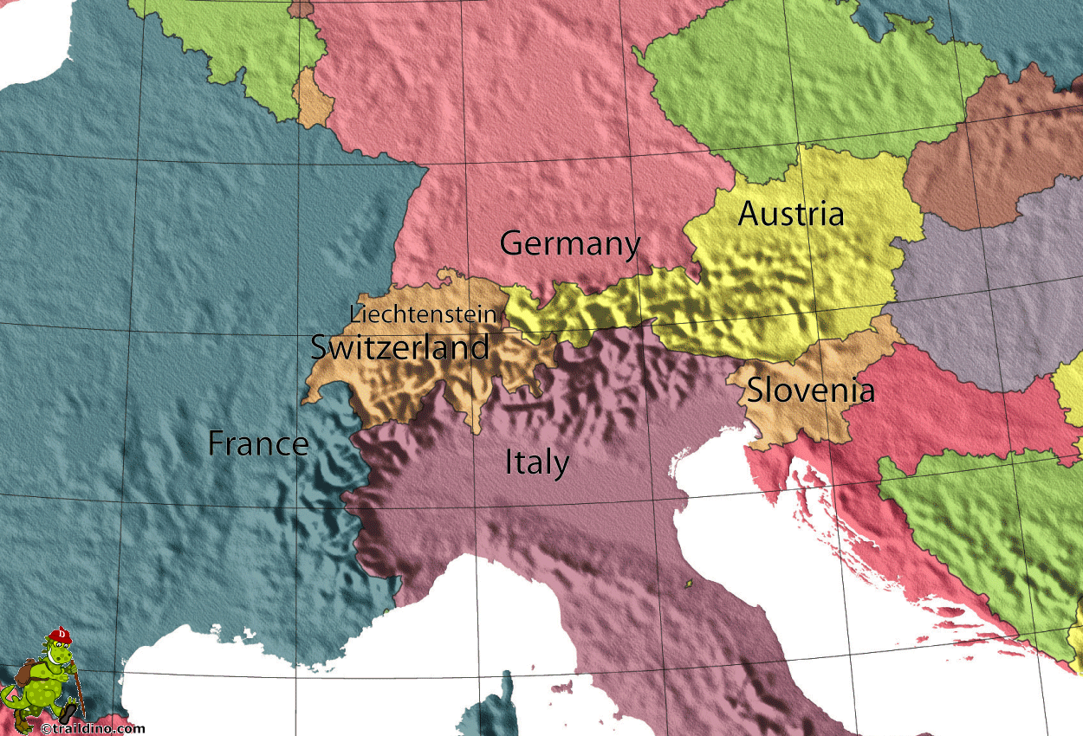
Map showing the location of the Alps in Europe

Matching Activity

Words - harsh, peaks, prone, adventurous, dominant, tectonic plates, massive, collided, irrigate

Definition | Enter your answer to match the definition
Large, moving pieces of the Earth’s outer layer | Click or tap here to enter text.
Pointed summit of mountains | Click or tap here to enter text.
Rough on the senses; severe or cruel | Click or tap here to enter text.
Large in mass; bulky; impressive or imposing | Click or tap here to enter text.
Having an inclination to do something; a tendency | Click or tap here to enter text.
To supply with water | Click or tap here to enter text.
Crash together with a violent impact | Click or tap here to enter text.
Occupying a commanding position | Click or tap here to enter text.
Daring or enterprising | Click or tap here to enter text.

