Writing - Summer 1 Week 3 - Home Learning
Session 4
In this session, you will be planning your portal story.
How to share your work:
- Write your answers into your exercise book and take a picture of your work.
- Type your answers directly into the boxes on this page or use Google Docs to edit.
Once you’ve completed the work, submit your work to Google Classroom following this set of instructions:
- Go to classroom.google.com
- Click the class - Classwork - the assignment.
- To attach an item, click ‘Add or create’ and select ‘Google Drive’, ‘Link’ or ‘File’ depending on what type of file you have created.
- The status of your work will change to ‘Turned in’.

Planning a Portal Story

Nearly all portal stories follow a similar pattern:
- Main character finds magical portal and enters new world
- Describe new world
- Main character explores this new world and encounters a problem
- Main character has to escape and return through the portal
- Main character cannot find the portal again (sometimes s/he brings back a memento of the new world).
Once you have identified the pattern of the story, the possibilities are endless. Let your imagination run free. Brainstorm lots of ideas and then decide which captures your interest as a writer. Before you start, take a look at these top tips.
Top tips for story writing:
• Start in a world/a setting that you know well – it is far easier to describe something familiar to you, e.g. a garden, your school, your local town, etc.
• Use a stimulus (e.g. picture) for the new world – an image will help you focus in on the detail and describe what is there (see next page for examples).
• Let your ideas flow – don’t worry about spelling, handwriting or presentation … you can go back and edit this later.

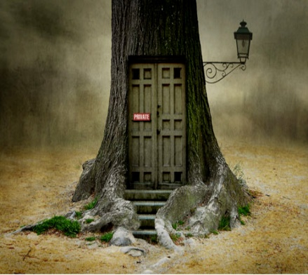
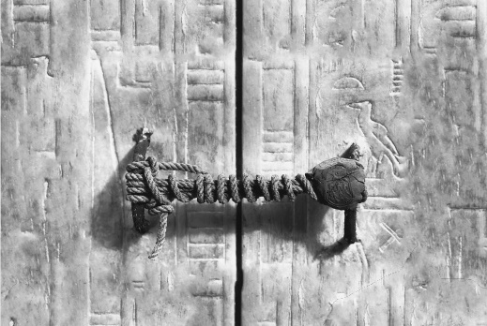
Picture Stimulus
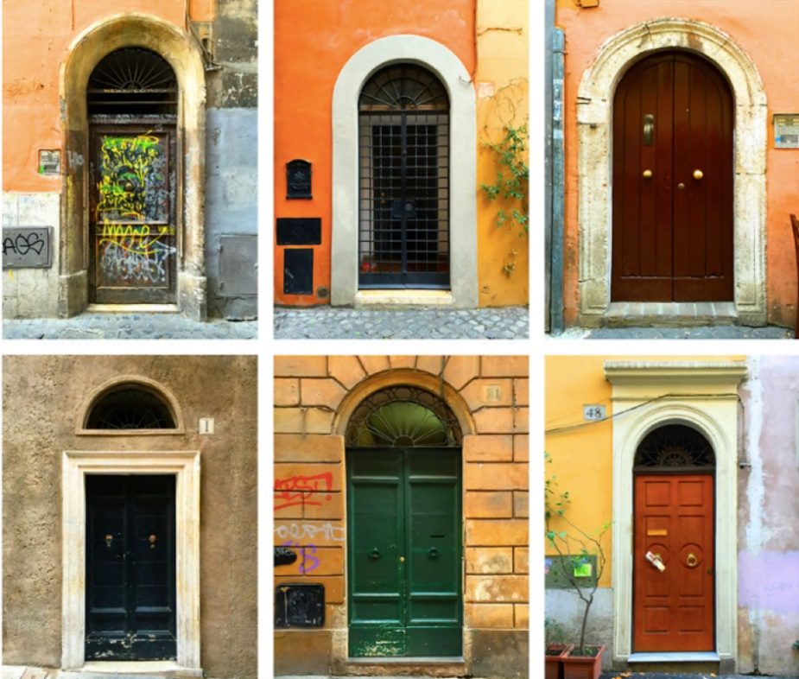

Idea Examples

Underlying Pattern | Story Idea 1 | Story Idea 2
Main character finds magical portal and enters new world | Elif is playing in her  Grandmother’s garden  and notices a small fairy  door. Touches door and  shrinks/ enters. | Josh and Archie playing  hide and seek in their house. Archie opens  hatch in the roof and  discovers new world.
Describe new world | Arrives in an underground world full of caves, giant  toadstools and magical  creatures. | Transported to life  onboard an enormous  sailing ship in Tudor England.
Main character explores this new world and encounters a problem | Elif explores new world  and enters an area strictly forbidden. Picks magical flower. | Ship is thrown into battle.
Main character has to escape and return through the portal | Alarms sound and Elif runs. She is chased through the magical world by unknown threat and escapes. | Archie desperately  searches for portal and  way back to own world.
Main character cannot find the portal again (sometimes s/he brings back a memento of the new world). | Elif cannot find fairy door again, but the cut flower lives on forever reminding her of her journey. | Archie escapes with  small pouch of gunpowder in his pocket.

Using the underlying pattern, plan a few portal stories of your own (you can use the plan on the next page). You may like to draw upon your own personal experiences as well as your wider reading and imagination.

My Ideas/Plan

Underlying Pattern | Story Idea 1 | Story Idea 2
Main character finds magical portal and enters new world | Click or tap here to enter text. | Click or tap here to enter text.
Describe new world | Click or tap here to enter text. | Click or tap here to enter text.
Main character explores this new world and encounters a problem | Click or tap here to enter text. | Click or tap here to enter text.
Main character has to escape and return through the portal | Click or tap here to enter text. | Click or tap here to enter text.
Main character cannot find the portal again (sometimes s/he brings back a memento of the new world). | Click or tap here to enter text. | Click or tap here to enter text.

