Science - Summer 1 Week 3 - Home Learning

Session 3
In this session, you will be looking at the features of a non-chronological report and using the information from ‘Why Exercise’ and what you know about the effects of exercise on the circulation system to create a weekly exercise programme for a parent/carer. You should already know the features of a non-chronological report, but if you have forgotten, they are listed below. Be sure to read all the information provided below to ensure your writing is fit for purpose.
How to share your work:
- Write your non-chronological report into your exercise book and take a picture of your work.
- Type your work directly into a Word document or use Google Docs.
Once you’ve completed the work, submit your work to Google Classroom following this set of instructions:
- Go to classroom.google.com
- Click the class - Classwork - the assignment.
- To attach an item, click ‘Add or create’ and select ‘Google Drive’, ‘Link’ or ‘File’ depending on what type of file you have created.
- The status of your work will change to ‘Turned in’.

Success Criteria

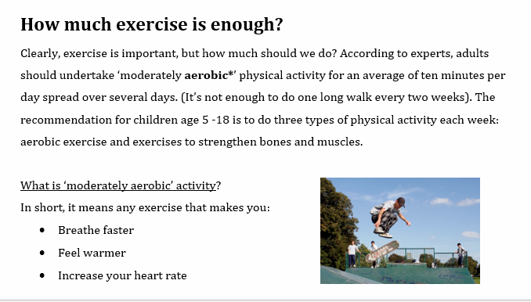

Question | Answer
What is the purpose of my writing? | To inform and peresuade
Who is the audience for my writing? | Parent/carer
How will I organise it? | Headings and subheadings
How will I make it engaging for the reader? | Use diagrams, pictures and ‘Did You Know?’ boxes
What other features are worthwhile noting? | Present tense (usually)  Technical/scientific vocabulary  Third person  Formal language

Example Plan

TITLE
Introduction - What are you writing this for and why?
Section 1 - Why do we need to exercise?
Heading and information
Could add a picture, diagram, bullet points or a ‘Did you know’ box
Section 2 - How much exercise should be taken and why?
Heading and information
Could add a picture, diagram, bullet points or a ‘Did you know’ box
Section 3 - The Programme (daily guide on activity type and amount)
This could be a table of informaiton
Conclusion

Greater Depth Options:
- Can you include an informal paragraph to contrast with the formality of your text?
- Can you use a range of punctuation to add detail and clarify meaning?
Sentence Openers | Scientific Vocabulary
Another reason …  Furthermore, …  In addition, …  Consequently, …  As a result of …  Although…  Because …  Even though …  Despite … | heart rate  cardiovascular  muscle  oxygen  aerobic  blood vessels  exercise  endorphins  physical activity

