Science - Summer 1 Week 3 - Home Learning

Session 1

In this session, we are going to look at some information about exercise. We will be recapping how to retrieve information from both text and graphs/diagrams. You will then have the chance to practice these skills using a different text in the next session.

How to share your work:

* Write your answers into your exercise book and take a picture of your work.
* Type your work directly into this document or use Google Docs.

Once you’ve completed the work, submit your work to Google Classroom following this set of instructions:

1. Go to classroom.google.com
2. Click the class - Classwork - the assignment.
3. To attach an item, click ‘Add or create’ and select ‘Google Drive’, ‘Link’ or ‘File’ depending on what type of file you have created.
4. The status of your work will change to ‘Turned in’.

How much exercise should we take?

It is recommended that, to be physically active, adults should be doing an activity:

* + for 10 minutes or more.
  + which is moderately aerobic.
  + which is spread over several days.
* A survey of 198,911 people was conducted to find out how active they were, to help find out how much of the population of England were exercising.
* From this sample, 44% were male and 56% were female.

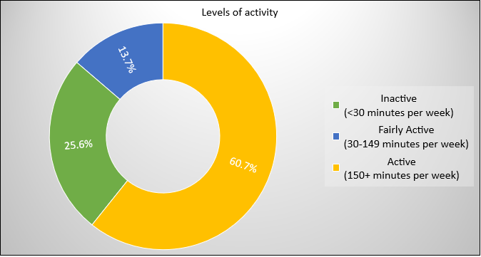

Inactive

Fairly Active

Active

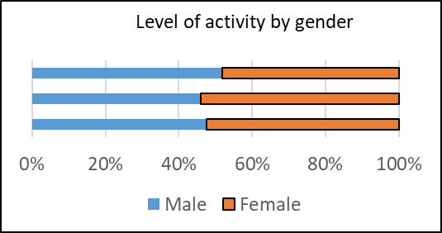

|  |  |  |  |
| --- | --- | --- | --- |
| **Name** | **Resting heart rate (beats per minute)** | **Heart rate after warm -up**  **(beats per minute)** | **Heart rate after 10 minutes of hockey**  **(beats per minute)** |
| **Lillie** | 92 | 104 | 118 |
| **Mason** | 79 | 97 | 128 |
| **Harry** | 79 | 96 | 131 |
| **Sapna** | 70 | 89 | 116 |
| **Leroy** | 85 | 105 | 127 |

The following data was collected from a group of children. Their heart rate was measured at rest, after a warm-up then after 10 minutes of playing a vigorous hockey match.

Moderate activity will raise your heart rate and make you breathe faster and feel warmer.

**What counts as moderate aerobic activity?**

Examples of activities that require moderate effort for most people:

* + - walking quickly
    - water aerobics
    - riding a bike on level ground or with few hills
    - pushing a lawn mower
    - hiking
    - skateboarding
    - rollerblading
    - volleyball
    - basketball

Retrieving Information

From text:

How many people were involved in the survey?

It is recommended that, to be physically active, adults should be doing an activity:

* + for 10 minutes or more.
  + which is moderately aerobic.
  + which is spread over several days.
* A survey of 198,911 people was conducted to find out how active they were, to help find out how much of the population of England were exercising.
* From this sample, 44% were male and 56% were female.

Click or tap here to enter text.

How long should an adult exercise daily?

Click or tap here to enter text.

In the second paragraph, **find** and **copy** the word which means ‘carried out’.

Click or tap here to enter text.

From a graph:

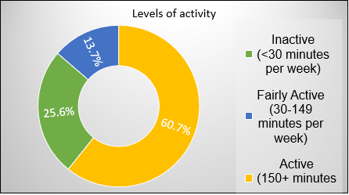What percentage of the adults were ‘fairly active’?

Click or tap here to enter text.

If someone exercised for 140 minutes per week, which category would they fit into?

Inactive

Fairly Active

Active

|  |  |  |  |
| --- | --- | --- | --- |
| **Name** | **Resting heart rate (beats per minute)** | **Heart rate after warm -up**  **(beats per minute)** | **Heart rate after 10 minutes of hockey**  **(beats per minute)** |
| **Lillie** | 92 | 104 | 118 |
| **Mason** | 79 | 97 | 128 |
| **Harry** | 79 | 96 | 131 |
| **Sapna** | 70 | 89 | 116 |
| **Leroy** | 85 | 105 | 127 |

From a table:

Who had the highest heart rate after exercise?

Click or tap here to enter text.

Who had the lowest heart rate before exercising?

Click or tap here to enter text.

**Remember:** When answering comprehension questions, you must follow these steps:

1. Read the question carefully.
2. Underline/highlight/make a note of key words (or numbers).
3. Scan the text for the key words or numbers.
4. Read the information around the key words.
5. Answer the question.