Science - Summer 1 Week 3 - Home Learning

Session 4
In this session, you will be constructing and interpreting line graphs.
How to share your work:
- Write your answers into your exercise book and take a picture of your work.
- Type your work directly into this document or use Google Docs.
- Create your line graph on squared/graph paper and take a picture or use an online tool to help you. You could experiment with a line graph on Excel if you have access to it.
Once you’ve completed the work, submit your work to Google Classroom following this set of instructions:
- Go to classroom.google.com
- Click the class - Classwork - the assignment.
- To attach an item, click ‘Add or create’ and select ‘Google Drive’, ‘Link’ or ‘File’ depending on what type of file you have created.
- The status of your work will change to ‘Turned in’.

Constructing and Interpreting Line Graphs

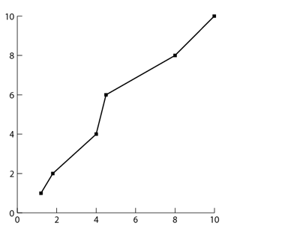

What could this graph be showing?
Click or tap here to enter text.

What is misisng from this graph?
Click or tap here to enter text.

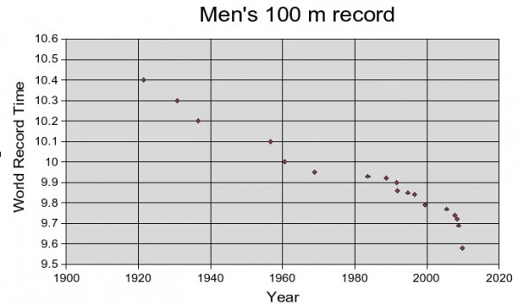
What does this graph show?
Click or tap here to enter text.

How do you know?
Click or tap here to enter text.

Will the times continue to get faster or is there a limit? If you believe there is a limit, what is that limit?
Click or tap here to enter text.

What was the time for the 100m in approximately 1930?
Click or tap here to enter text.

In which year was the 100m run in approxiately 9.8 second?
Click or tap here to enter text.
Success Criteria for a Line Graph

- Axes labelled at regular intervals.
- Axes labelled with units of measurement.
- Points plotted precisely.
- Points connected precisely.
- A clear title to explain the content.

Your turn:
Use the data from the text ‘Why Exercise?’ (attached again below) to construct a line graph showing the changes in heart rates for the children. You can edit the graph paper which is attached.

To conclude:
Can you predict what will happen to the heart rate 5 minutes after exercise? Draw your prediction on the graph.

Text

Why Exercise?

Increasingly, experts are concerned about the health of people in England. More specifically, the amount of exercise which is taken by them. It is widely established that regular exercise has many health benefits: a stronger heart, more efficient lungs and the maintenance of a healthy body weight. Furthermore, apart from the physical benefits which exercise provides, there are also well-known mental ones. By exercising, people are generally more alert and the body also releases chemicals, called endorphins, which trigger a positive feeling and add to mental wellbeing.

How much exercise is enough?
Clearly, exercise is important, but how much should we do? According to experts, adults should undertake ‘moderately aerobic*’ physical activity for an average of ten minutes per day spread over several days. (It’s not enough to do one long walk every two weeks). The recommendation for children aged 5 -18 is to do three types of physical activity each week: aerobic exercise and exercises to strengthen bones and muscles.
What is ‘moderately aerobic’ activity?
In short, it means any exercise that makes you:
- Breathe faster
- Feel warmer
- Increase your heart rate

For example, you could play basketball, volleyball football or netball. Or you could go skateboarding, bike riding, rollerblading or hiking. There must be something you’d enjoy!

How active are we?
How do the English measure-up to these recommendations? A recent survey of nearly 200,000 people was carried out to determine just how much exercise people were actually doing.

Level of activity Percentage of population
Inactive (less than 30 minutes per week) 25.6%
Fairly active (30-149 minutes per week) 13.7%
Very active (150 or more minutes per week) 60.7%

How does your heart rate change?
Some children wanted to find out how much their heart rate was affected by exercise. First, they measured their resting heart rate. Then they measured again after the warm-up (which was brisk walking whilst dribbling a basketball). Finally, they measured their heart rate straight after playing 10 minutes of fast-paced basketball. This is what they found:

Name | Resting heart rate (beats per minute) | Heat rate after warm -up  (beats per minute) | Heat rate after 10 minutes of basketball  (beats per minute)
Lillie | 95 | 98 | 102
Mason | 89 | 97 | 138
Harry | 77 | 84 | 96
Sapna | 73 | 78 | 98
Leroy | 82 | 100 | 122

They concluded that the effect of exercise is to make the heart beat faster. From their results, they also noticed that the more vigorous the exercise (a basketball match) the higher the heart rate. Because the heart is a muscle, this means that vigorous exercise should make the heart stronger as it is working harder.
So, how active are you? Why not keep an exercise diary and identify how you could become more active and healthier, both physically and mentally?

* aerobic exercise is physical activity of low to high intensity (sometimes known as ‘cardio’) which stimulates the use of the heart and lungs.

