Writing - Summer 1 Week 1 - Home Learning

Session 2
Read through the model newspaper report based on ‘The Visitor’.
Create a Boxed Success Criteria for a newspaper report. Remember that PAF stands for Purpose, Audience and Form.
P: What is the purpose of this writing? To inform, to persuade, to argue, to entertain etc.
A: Who is the audience of your writing?
F: What form does your writing take? Is it a story, a non-chronological report, a diary, etc.
How to share your work:
- Draw your Boxed Success Criteria into your exercise book and take a picture of your work.
- Type your work up.
Once you’ve completed the work, submit your work to Google Classroom following this set of instructions:
- Go to classroom.google.com
- Click the class - Classwork - the assignment.
- To attach an item, click ‘Add or create’ and select ‘Google Drive’, ‘Link’ or ‘File’ depending on what type of file you have created.
- The status of your work will change to ‘Turned in’.

Model Newspaper Report

Mysterious Metal Giant Descends on Town!
Yesterday evening, visitors to the Lexicon were left shocked and confused after the arrival of a giant, robot-like figure.  At around 8pm, diners sat in the restaurants in the centre of Bracknell began to hear unexplained snaps and clicks. As the sounds became louder, people began to leave their meals and gather on the streets to discover the source of the sounds. A children’s party, which was made up of eight nine-year-old boys, were the first to spot the metal humanoid towering over the Lexicon. They told us that they spotted it just as its foot sunk into a building that is still under construction. Luckily, this meant it was empty so there were no casualties.  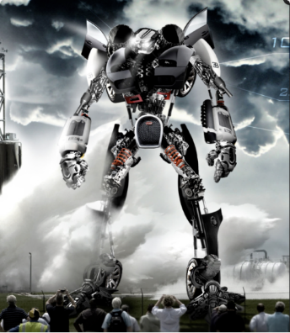  A photograph taken by restaurant manager, James, who was working in one of the restaurants in the Lexicon. | As the crowds began to gather and stare open-mouthed at the metal giant, it appeared to become inanimate and ceased to move any further. Despite this, police made sure that the bystanders did not get within 50m of the towering figure in case it turned hostile.  When we asked for a comment from the Mayor of Bracknell, he said that they have still been unable to determine whether the visitor is being controlled internally or remotely or if it is making its own choices. He was also unable to comment about whether the residents of Bracknell are safe but suggested people ‘continue to be vigilant’ when moving around outside. Many people, who were in the area at the time, were understandably too shocked to talk to our reporter. However, Ben, one of the boys who first saw the figure, said the following: ‘I am both amazed and a little bit scared. The robot looks really cool but I don’t know if it’s friendly or not.’  At present, local officials are still trying to determine where the mysterious visitor has come from and what its purpose is. They have assured us that the public will be updated as soon as they know more.
Boxed Success Criteria
