Writing - Summer 1 Week 1 - Home Learning

Session 1
Look at the picture titled The Visitor and read the background information. Consider the following questions:
- Who do you think is controlling the robot? Does it have a mind of its own?
- Where has the robot come from?
- Are the people in danger?
- Can you think of a good name for the robot?
- Is there a chance that robots will become part of our society in the future?
Using the questions above, and your own imagination answer these 5 W questions:
- When is this taking place?
- Where is the setting for this?
- Who is this about?
- What has happened?
- Why has it happened?
Now, put the answers to the W questions into a paragraph of coherent sentences.
How to share your work:
- Write your answers into your exercise book and take a picture of your work.
- Type your answers directly into the boxes on this page.
Once you’ve completed the work, submit your work to Google Classroom following this set of instructions:
- Go to classroom.google.com
- Click the class - Classwork - the assignment.
- To attach an item, click ‘Add or create’ and select ‘Google Drive’, ‘Link’ or ‘File’ depending on what type of file you have created.
- The status of your work will change to ‘Turned in’.

The Visitor
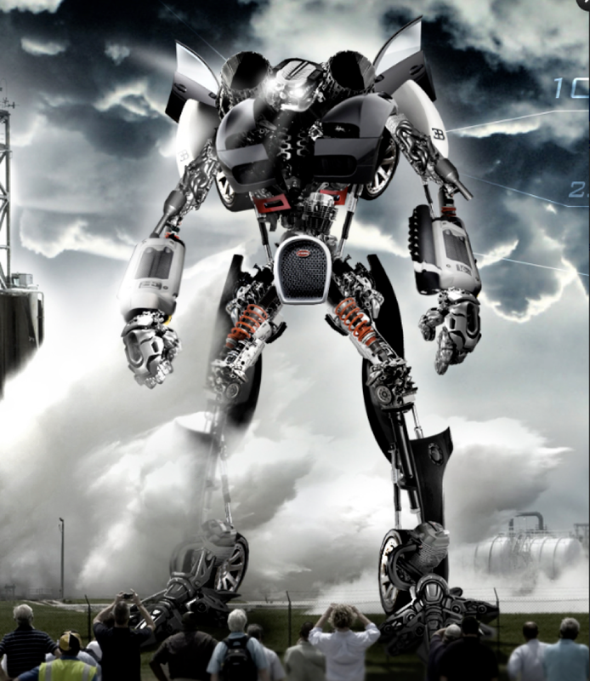

Background Information:
Snap...Snap...Click...The sound of a hundred cameras filled the air.

Craning their necks to the skies to see the enormous specimen, the crowd all let out gasps and moans in unison as the figure took its first steps.

Standing over 50 metres tall, the metal beast cast a foreboding shadow over the gathering, transfixed spectators. No-one knew why it was here. No-one knew where it had come from. No-one knew whose side it was on. However, its intentions were about to be made clear...
The 5 Ws

When is this taking place? | Click or tap here to enter text.
Where is the setting for this? | Click or tap here to enter text.
Who is this about? | Click or tap here to enter text.
What has happened? | Click or tap here to enter text.
Why has it happened? | Click or tap here to enter text.

My Paragraph:
Click or tap here to enter text.

