Reading - Summer 1 Week 1 - Home Learning

Session 3
Complete the comprehension questions.

Extension activity
There is a final challenge relating to the text. You can do this in your exercise books or on a larger sheet of paper. We will be very keen to see what everyone comes up with!

How to share your work:
- Type your responses directly into this document.
Once you’ve completed the work, submit your work to Google Classroom following this set of instructions:
- Go to classroom.google.com
- Click the class - Classwork - the assignment.
- To attach an item, click ‘Add or create’ and select ‘Google Drive’, ‘Link’ or ‘File’ depending on what type of file you have created.
- The status of your work will change to ‘Turned in’.

Session 3 - Discursive Text
Evacuation - for and against
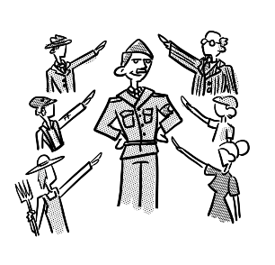
In the late 1930s, there was a growing realisation that war was coming. Nazi Germany, led by Adolf Hitler, had been acting aggressively and there was fear across the UK that this country would get caught up in the conflict. Along with a threat of invasion came a new danger. Aircraft had been developing rapidly over the first four decades of the twentieth century and there were now bombers capable of reaching cities deep inside enemy territory.
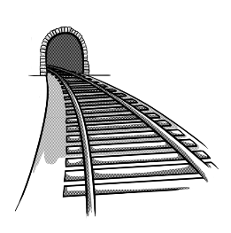
Anxious for the fate of its citizens, the British Government launched Operation Pied Piper on the 1st September 1939 - two days before war broke out. Hundreds of thousands of children were assembled with only a handful of possessions and loaded onto trains and buses and evacuated into the countryside. Within the first few days of this extraordinary undertaking, over one and a half million children had been evacuated. The question is, was it the right thing to do?
The authorities certainly believed it was necessary. Any Government has a duty to safeguard its people and the first thing you can do for those at risk is to remove them from danger. No one would have claimed that removing children from their parents would be painless, but they had to consider the bigger picture.
Nor could anyone say that the Government was crying wolf. Most of the country’s major cities were, indeed, attacked by waves of bombers, night after night. Some areas, such as Coventry and the East End of London, were absolutely devastated with thousands of people losing their lives. No matter what hardships the evacuees might have faced, at least they were spared the main horrors of war. Some even enjoyed it and gained probably their first experience of living in the countryside.
On the other hand, you might wonder whether this ambitious plan was properly thought through. Physical injuries are often obvious but some scars cannot be seen and we are only just beginning to appreciate the damage that can be caused by separation. What’s more, it wasn’t just the children who suffered: the parents also hated seeing their little ones being taken away.
Furthermore, there wasn’t time to assess whether they were being sent to suitable homes with caring, sympathetic people. It is clear that some of those who were told to accept the evacuees really did not want their lives disrupted by the arrival of strange children so we can imagine how awkward it might have been.
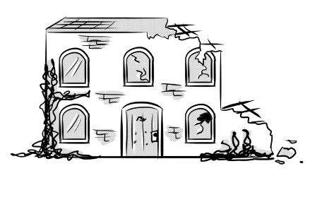
We can all be wise in hindsight. In the end, most of the children were safely reunited with their families as the threat of German invasion faded. Some, however, returned to find that their parents had perished and their communities had been destroyed. Was it worth the pain? More importantly, if we ever find ourselves in a similar situation, should we attempt another programme of widespread evacuation?

Session 3 - Questions for Evacuation - for and against

1. Look at the first paragraph. Find and copy a word that means quickly.
Click or tap here to enter text.

2. Look at the second paragraph. Within the first few days of this extraordinary undertaking... What does undertaking mean in this sentence? Tick one.

task ☐ journey ☐

theft ☐ question ☐

3. ‘just beginning to appreciate’. In this sentence, appreciate means:
Click or tap here to enter text.

4. Who was leader of Nazi Germany?
Click or tap here to enter text.

5. When was Operation Pied Piper launched?
Click or tap here to enter text.

6. Which two places does the text say were devastated by waves of bombers?
Click or tap here to enter text.

7. Apart from bombing, what did the British worry that the Germans would do to their country?
Click or tap here to enter text.

8. Nor could anyone say the Government was crying wolf. Explain what this means.
Click or tap here to enter text.

9. ‘some scars cannot be seen ‘. What do you think the author means by this?
Click or tap here to enter text.

10. Below are some summaries of different paragraphs from the text.
Number them from 1 to 5 to show the order in which they appear in the text.

Parts of the UK were heavily bombed. | Choose an item.
People were upset by the evacuation. | Choose an item.
The British were worried that a war was coming. | Choose an item.
Children returned to their homes. | Choose an item.
The Government started evacuating children. | Choose an item.

11. Based on what you have read, name one thing you think the Government would improve for any future evacuation.
Click or tap here to enter text.

12. Look at the fifth and sixth paragraphs. They both give arguments against evacuation but from a different perspective. Explain how.
Click or tap here to enter text.

Session 3 - Extension activity
What did Evacuee Boys and Girls have to put into their suitcase?

This list of clothes for Evacuee boys and girls was sent to every family in a city by the British Government. The list told families what to pack in their children’s suitcases if they were going to be evacuated. This was meant to show the minimum amount of different clothes to pack.
However, many families from the cities were very poor and so their children’s suitcases often contained very few of these clothing items.
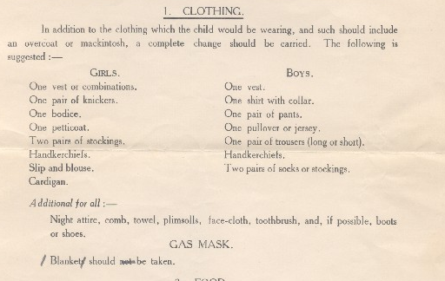

In addition, children would have an identity card and their ration book with them, along with a small toy and, of course, their gas mask.

Your task is to design an information poster, telling parents what to pack for their children. The format and design is totally up to you, but you can use the suitcase template below if you would like to. Think about making the poster easy to read and understand, and what are the key pieces of information to include.

